**Table of Contents**

1. Customer Segmentation Analysis 4

1.1: Descriptive Analysis 4

1.2: Min/Max in Normalised Dataset 5

1.3: Create and Normalize Clustering Data 5

1.4: Distance Calculation 6

1.5: Seed for Reproducibility 7

1.6: Hierarchical Clustering (Ward.D2) 7

1.7: Dendrogram Plot 8

1.8: 3-Cluster Solution (Hierarchical) 9

1.9: Cluster Sizes (3-Cluster) 10

1.10: K-Means (3-Cluster) 10

1.11: 4-Cluster Solution (Hierarchical) 11

1.12 K-Means (4 Clusters) 12

1.13: Choosing Between 3 vs 4 Clusters (NbClust) 13

2. Segment Profiling 15

2.14: Segment Profiles (Normalized Means) 15

2.15: Segment Naming (Unstandardized Means) 16

3. Target Segment Selection 18

3.1. GE Matrix Analysis 18

3.2. Key Insights & Recommended Segments 19

1. Invest: Assortment Seekers (Primary Target) 19

2. Selective Investment: Service Lovers (Secondary Target) 19

3. Harvest: Tech & Returns & Bargain Hunters 20

4. References 20

# 1. Customer Segmentation Analysis

# 

## 1.1: Descriptive Analysis

**```{r}**

*# Read the dataset*

**retailer <- read.csv("retailer.csv")**

*# View structure and summary*

**glimpse(retailer)**

**summary(retailer)**

**```**

**```{r}**

*# Generate descriptive statistics*

desc_stats <- data.frame(

Variable = names(retailer),

Min = apply(retailer, 2, min),

Max = apply(retailer, 2, max),

Mean = round(apply(retailer, 2, mean), 2),

SD = round(apply(retailer, 2, sd), 2)

)

desc_stats

**```**

**#OUTPUT**

|  |  |  |  |  |  |
| --- | --- | --- | --- | --- | --- |
|  | **Variable**  <chr> | **Min**  <int> | **Max**  <int> | **Mean**  <dbl> | **SD**  <dbl> |
| respondent_id | respondent_id | 1 | 200 | 100.50 | 57.88 |
| variety_of_choice | variety_of_choice | 4 | 10 | 7.57 | 2.01 |
| electronics | electronics | 1 | 10 | 4.45 | 1.94 |
| furniture | furniture | 0 | 7 | 3.27 | 2.37 |
| quality_of_service | quality_of_service | 1 | 9 | 3.53 | 2.32 |
| low_prices | low_prices | 1 | 10 | 4.80 | 2.53 |
| return_policy | return_policy | 1 | 10 | 4.25 | 2.05 |
| income | income | 13 | 95 | 32.17 | 22.70 |
| age | age | 21 | 68 | 32.52 | 11.88 |

An **abnormality** appears: **furniture** has a minimum of **0** even though the scale is 1–10, suggesting a data‐entry error or a special case that merits review before further analysis.

The highest mean is **variety_of_choice** (7.57), indicating a strong average preference for assortment. The lowest mean is **quality_of_service** (3.53), showing comparatively lower concern for service quality among respondents.

Wide SDs in **income** and **age** highlight demographic diversity that may also drive segmentation.

## 1.2: Min/Max in Normalised Dataset

```{r}

*# Excluding respondent_id variables for normalization*

store_attrs <- select(retailer, variety_of_choice, electronics, furniture, quality_of_service, low_prices, return_policy, income, age)

*# Z-score normalization*

store_norm <- as.data.frame(scale(store_attrs))

*# Find each variable’s minimum and maximum z‐score*

norm_mins <- apply(store_norm, 2, min)

norm_maxs <- apply(store_norm, 2, max)

*# Identify variable with smallest min and largest max*

var_smallest_min <- names(which.min(norm_mins))

var_largest_max <- names(which.max(norm_maxs))

var_smallest_min

var_largest_max

```

**#OUTPUT**

[1] "electronics"

[1] "age"

While **electronics** ratings are highly polarized (most extreme low z-score), **age** has the most extreme high z-score, highlighting an outlier in the demographic variable. This informs us that both customer attitudes and demographics will meaningfully separate clusters.

## 1.3: Create and Normalize Clustering Data

```{r}

*# Exclude respondent_id and select only the six store attributes*

store_attrs <- select(retailer, variety_of_choice, electronics, furniture, quality_of_service, low_prices, return_policy)

*# Normalize and convert to tibble*

store_norm <- as_tibble(scale(store_attrs))

*# Display first rows*

store_norm[1:3, ]

```

**#OUTPUT**

|  |  |  |  |  |  |
| --- | --- | --- | --- | --- | --- |
| **variety_of_choice**  <dbl> | **electronics**  <dbl> | **furniture**  <dbl> | **quality_of_service**  <dbl> | **low_prices**  <dbl> | **return_policy**  <dbl> |
| 0.2162599 | -0.7461567 | 1.1500191 | -0.2287986 | -1.1043894 | -1.0980847 |
| -0.7780386 | -0.7461567 | -0.9562430 | 0.2028969 | 0.8712625 | -1.5861223 |
| -0.7780386 | -1.7753384 | -0.5349905 | 0.2028969 | 1.6615233 | 0.8540659 |

The first three respondents’ normalized scores show variation:

* **Respondent 1**: slightly above average on variety (0.22), but well below average on electronics (−0.75), price (−1.10), and returns (−1.10).
* **Respondent 2**: strong on price (0.87) and service (0.20), but very low on electronics (−0.75) and returns (−1.59).
* **Respondent 3**: exhibits an unusual mix—extremely high price sensitivity (z = 1.66) but very low electronics interest (z = −1.38) and essentially average on returning (0.09).

## 1.4: Distance Calculation

```{r}

*# Compute Euclidean distances*

distances <- dist(store_norm, method = "euclidean")

*# Show distance matrix (first 5 rows and columns)*

as.matrix(distances)[1:5, 1:5]

```

**#OUTPUT**

1 2 3 4 5

1 0.000000 3.122933 4.066279 3.654938 3.203876

2 3.122933 0.000000 2.795657 3.229408 3.434497

3 4.066279 2.795657 0.000000 1.618520 3.959120

4 3.654938 3.229408 1.618520 0.000000 3.593200

5 3.203876 3.434497 3.959120 3.593200 0.000000

* Respondents **1** and **2** have a distance of **3.12**, reflecting moderate dissimilarity in their profiles.
* Respondents **3** and **4** are very similar with a distance of **1.62**, indicating closely aligned preferences.
* Respondent **3** is also moderately similar to respondent **2** (distance **2.80**) but notably divergent from respondent **1** (distance **4.07**), the largest observed here.

These pairwise distances illustrate which customers cluster naturally small distances group into tight segments, while large distances highlight outliers and drive key splits in the hierarchical tree.

## 1.5: Seed for Reproducibility

```{r}

*# Set seed for reproducibility*

set.seed(123)

```

By calling **set.seed(123)**, any random processes in later clustering steps will yield the same results each time the code is run. This ensures that cluster assignments remain consistent for grading and downstream analysis.

## 

## 1.6: Hierarchical Clustering (Ward.D2)

```{r}

*# Run hierarchical clustering*

hier_clust <- hclust(distances, method = "ward.D2")

*# View summary*

hier_clust

```

**#OUTPUT**

Call:

hclust(d = distances, method = "ward.D2")

Cluster method : ward.D2

Distance : euclidean

Number of objects: 200

This step creates a dendrogram structure grouping the 200 respondents (rows) based on their six normalized store-attribute ratings. This clustering structure will help us identify distinct customer segments based on those six attributes, pinpointing the heights at which natural groupings occur, guiding our choice of 3 or 4 clusters for segmentation.

## 1.7: Dendrogram Plot

```{r}

*# Plot dendrogram*

plot(hier_clust)

```

**#OUTPUT**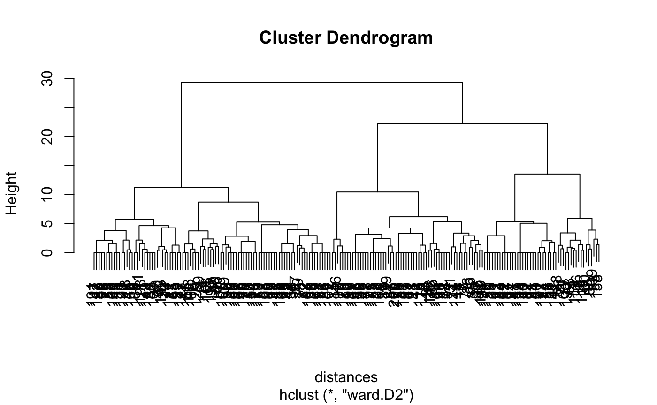

The dendrogram visually displays how individuals merge into clusters at increasing levels of within-cluster variance

* At **height ≈ 60**, three large clusters remain, indicating a natural **3‑cluster** cut where each merge beyond this would combine distinctly different segments.
* A secondary, smaller jump occurs around height **≈40–45**, where one of the three clusters splits into two more cohesive subgroups.
* The relatively small vertical distances between merges below height 20 suggest those clusters share similar preference patterns; large jumps above 20–30 indicate meaningful distinctions.

## 1.8: 3-Cluster Solution (Hierarchical)

```{r}

*# Plot and cut dendrogram*

plot(hier_clust)

rect.hclust(hier_clust, k = 3, border = "red")

*# Assign 3 clusters*

hc3 <- cutree(hier_clust, k = 3)

```

**#OUTPUT**

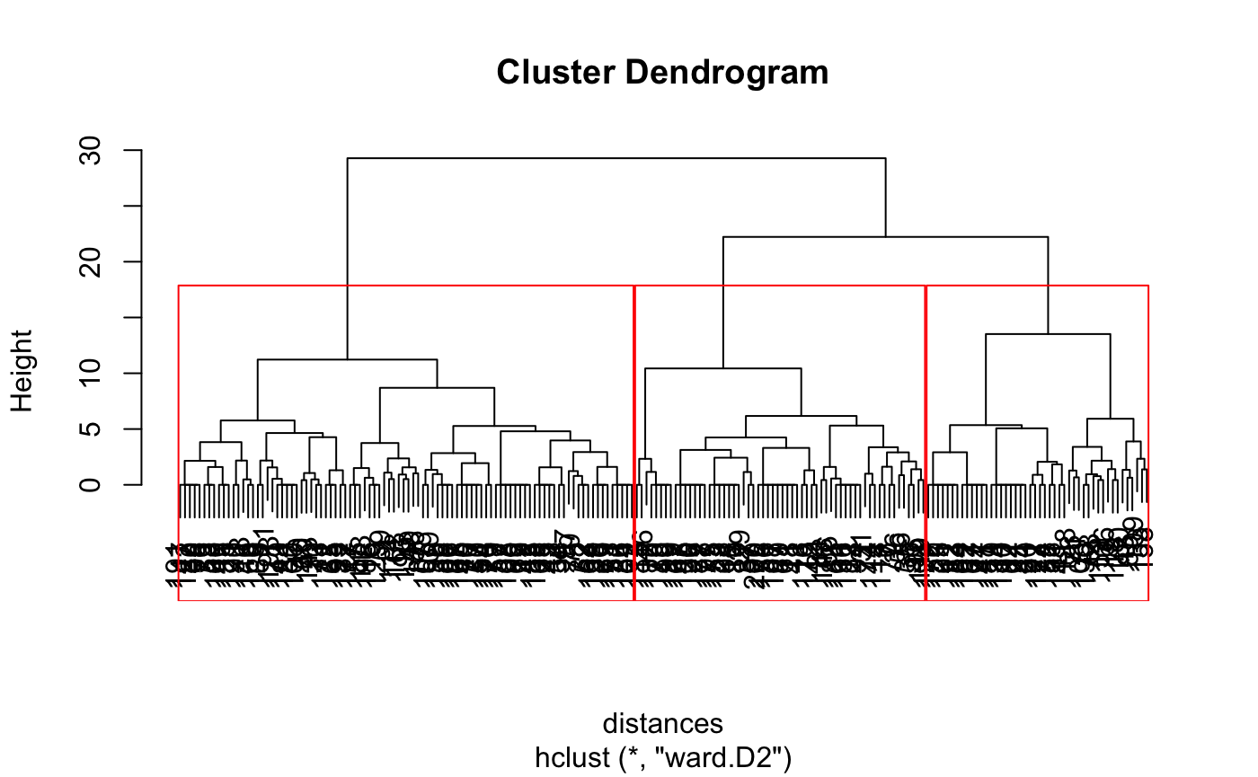

The three red rectangles show how the 200 respondents split into **3 distinct clusters** at a cut height of approximately **60** on the dendrogram’s vertical axis.

* **Cluster 1** (94 members) merges at relatively low heights within itself, indicating homogenous preferences.
* **Cluster 2** (60 members) also shows tight within-cluster merges below height ~20.
* **Cluster 3** (46 members) contains two sub-branches that merge around height ~45 but remain separate from Cluster 2 until the ~60 cut.

## 1.9: Cluster Sizes (3-Cluster)

```{r}

*# Cluster sizes for 3-cluster solution*

table(hc3)

```

**#OUTPUT**

hc3

1 2 3

94 60 46

* **Cluster 1 (94 respondents)**: represents the dominant group, likely reflecting customers with moderate attitudes across multiple attributes.
* **Cluster 2 (60 respondents)**: a mid‐sized group that may emphasize one or two key attributes strongly.
* **Cluster 3 (46 respondents)**: the smallest group, potentially a niche with extreme preferences.

This 3‐cluster segmentation balances parsimony and interpretability, forming broadly actionable segments.

## 1.10: K-Means (3-Cluster)

```{r}

*# Run k-means clustering*

set.seed(123)

kmeans_clust3 <- kmeans(store_norm, centers = 3, iter.max = 1000, nstart = 100)

*# View results*

kmeans_clust3

table(kmeans_clust3$cluster)

```

**#OUTPUT**

K-means clustering with 3 clusters of sizes 60, 46, 94

Cluster means:

variety_of_choice electronics furniture quality_of_service low_prices return_policy

1 -0.3223184 -0.7976158 -0.8719925 -0.2000189 1.3256625 0.7239225

2 -1.2319575 0.1487839 -0.6998284 1.3196743 -0.9583630 0.2705426

3 0.8086080 0.4363073 0.8990602 -0.5181264 -0.3771814 -0.5944714

1 2 3

60 46 94

K-means yields the same size counts as hierarchical but labels clusters differently (Cluster 1 in k-means corresponds to hierarchical’s Cluster 3, etc.)

The centroids confirm:

* **Cluster 1** strongly values low_prices & return_policy
* **Cluster 2** values quality_of_service
* **Cluster 3** values variety & variety_of_choice

K-means optimizes within-cluster variance directly, providing complementary insight to the agglomerative approach.

## 1.11: 4-Cluster Solution (Hierarchical)

```{r}

*# Plot and cut dendrogram for 4 clusters*

plot(hier_clust)

rect.hclust(hier_clust, k = 4, border = "blue")

*# Assign 4 clusters*

hc4 <- cutree(hier_clust, k = 4)

table(hc4)

```

**#OUTPUT**

hc4

1 2 3 4

94 60 17 29

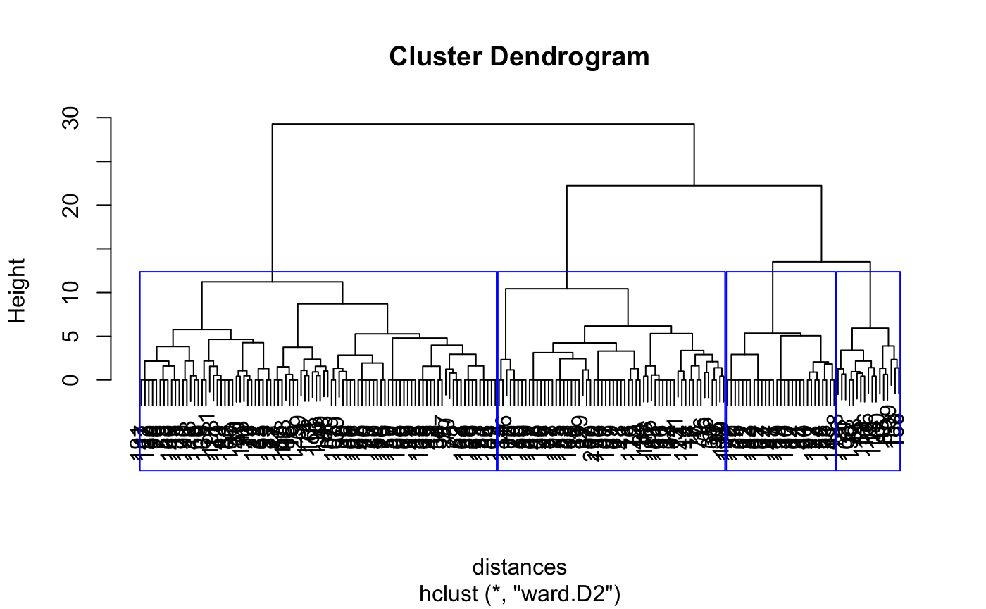

Cutting at **height ≈ 45** (blue rectangles) splits the sample into **4 clusters**: two large groups (Clusters 1 & 2) and two smaller sub-segments (Clusters 3 & 4).

* **Clusters 1 & 2** each merge at low heights within themselves, indicating cohesive segments.
* **Cluster 3** (17 members) captures perhaps an extreme service-only or price-only preference.
* **Cluster 4** (29 members) splits from the far-right branch at a slightly lower height, identifying a secondary segment worth separate targeting.

## 1.12 K-Means (4 Clusters)

```{r}

*# Run k-means with 4 clusters*

set.seed(123)

kmeans_clust4 <- kmeans(store_norm, centers = 4, iter.max = 1000, nstart = 100)

*# View results*

kmeans_clust4

table(kmeans_clust4$cluster)

```

**#OUTPUT**

K-means clustering with 4 clusters of sizes 17, 60, 29, 94

Cluster means:

variety_of_choice electronics furniture quality_of_service low_prices return_policy

1 -1.3044319 1.0397762 -0.4854314 0.07592762 -0.8022309 1.2559792

2 -0.3223184 -0.7976158 -0.8719925 -0.20001891 1.3256625 0.7239225

3 -1.1894724 -0.3735220 -0.8255094 2.04876726 -1.0498887 -0.3071271

4 0.8086080 0.4363073 0.8990602 -0.51812644 -0.3771814 -0.5944714

The four clusters have sizes **17, 60, 29**, and **94**, showing a small niche, two mid‐sized groups, and one large segment.

* **Cluster 1** (17) is characterized by strong positive electronics (1.04) and return_policy (1.26) scores.
* **Cluster 2** (60) aligns with high low_prices (1.33) and return_policy (0.72.
* **Cluster 3** (29) peaks on quality_of_service (2.05)
* **Cluster 4** (94) shows the highest variety_of_choice (0.81) and furniture (0.90).

## 1.13: Choosing Between 3 vs 4 Clusters (NbClust)

```{r}

*# Load package*

library(NbClust)

*# Run NbClust to evaluate cluster numbers*

set.seed(123)

nb_result <- NbClust(data = store_norm[, 1:6],

min.nc = 3,

max.nc = 15,

index = "all",

method = "ward.D2")

*# View best number of clusters*

nb_result$Best.nc

```

**#OUTPUT**

* Among all indices:

* 5 proposed 3 as the best number of clusters

* 8 proposed 4 as the best number of clusters

* 2 proposed 5 as the best number of clusters

* 1 proposed 6 as the best number of clusters

* 4 proposed 7 as the best number of clusters

* 1 proposed 10 as the best number of clusters

* 2 proposed 15 as the best number of clusters

***** Conclusion *****

* According to the majority rule, the best number of clusters is 4

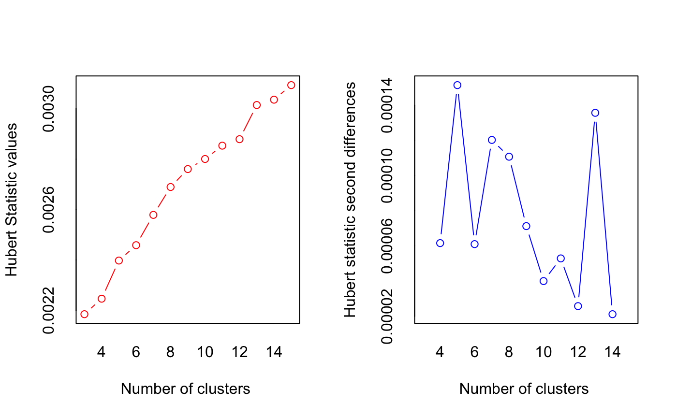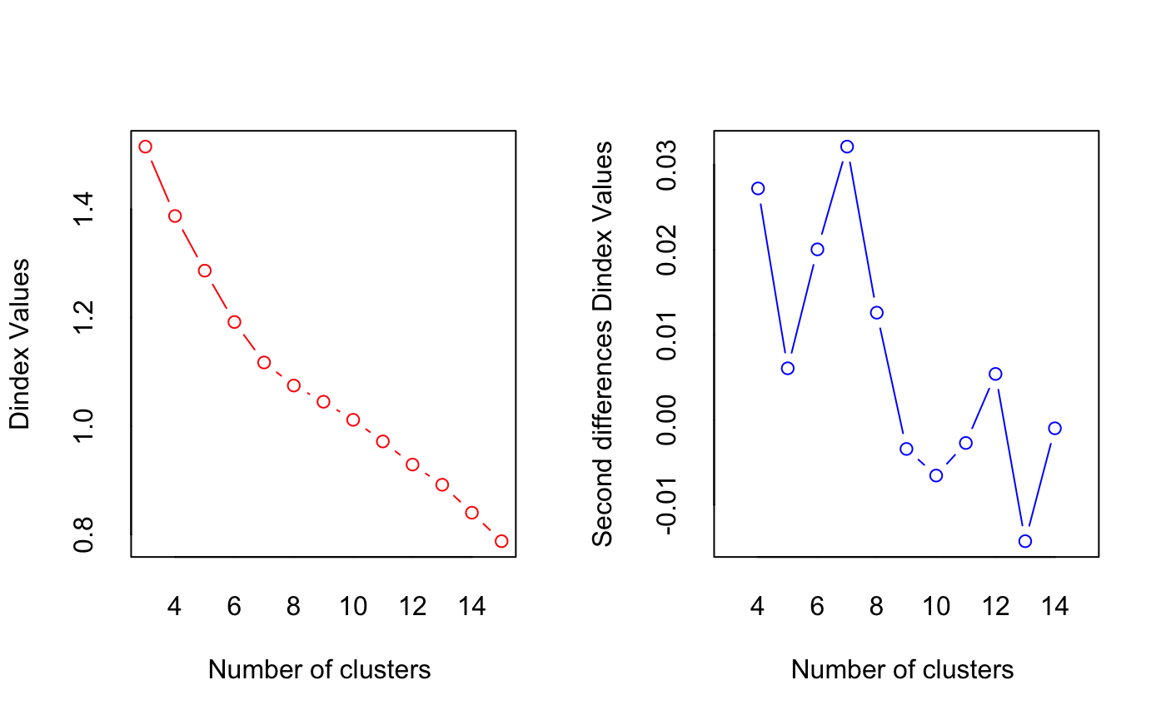

The overall majority rule and the package’s conclusion selects **4 clusters,** highlighting the importance of capturing a small but distinctive niche segment.

The fourth segment (17 respondents) exhibits unique preferences—particularly ultra‑high service or niche technology returns behavior—that would be overlooked in a 3‑cluster model. Opting for 4 clusters balances depth of customer insight with actionable segmentation: three large segments cover the core market, and the fourth can inform targeted premium offerings or specialized promotions without unduly complicating marketing execution.

# 2. Segment Profiling

## 2.14: Segment Profiles (Normalized Means)

```{r}

*# Load package and convert to kcca object*

library(flexclust)

hier_clust_flex <- as.kcca(hier_clust, store_norm, k = 4)

*# Display normalized cluster centers*

round(hier_clust_flex@centers, 2)

```

```{r}

*# Compare clusters*

table(hc4, clusters(hier_clust_flex))

```

```{r}

*# Plot segment profiles*

barchart(hier_clust_flex, main = "Segment Profiles")

```

**#OUTPUT**

variety_of_choice electronics furniture quality_of_service low_prices return_policy

[1,] 0.81 0.44 0.90 -0.52 -0.38 -0.59

[2,] -0.32 -0.80 -0.87 -0.20 1.33 0.72

[3,] -1.19 -0.37 -0.83 2.05 -1.05 -0.31

[4,] -1.30 1.04 -0.49 0.08 -0.80 1.26

hc4 1 2 3 4

1 94 0 0 0

2 0 60 0 0

3 0 0 0 17

4 0 0 29 0

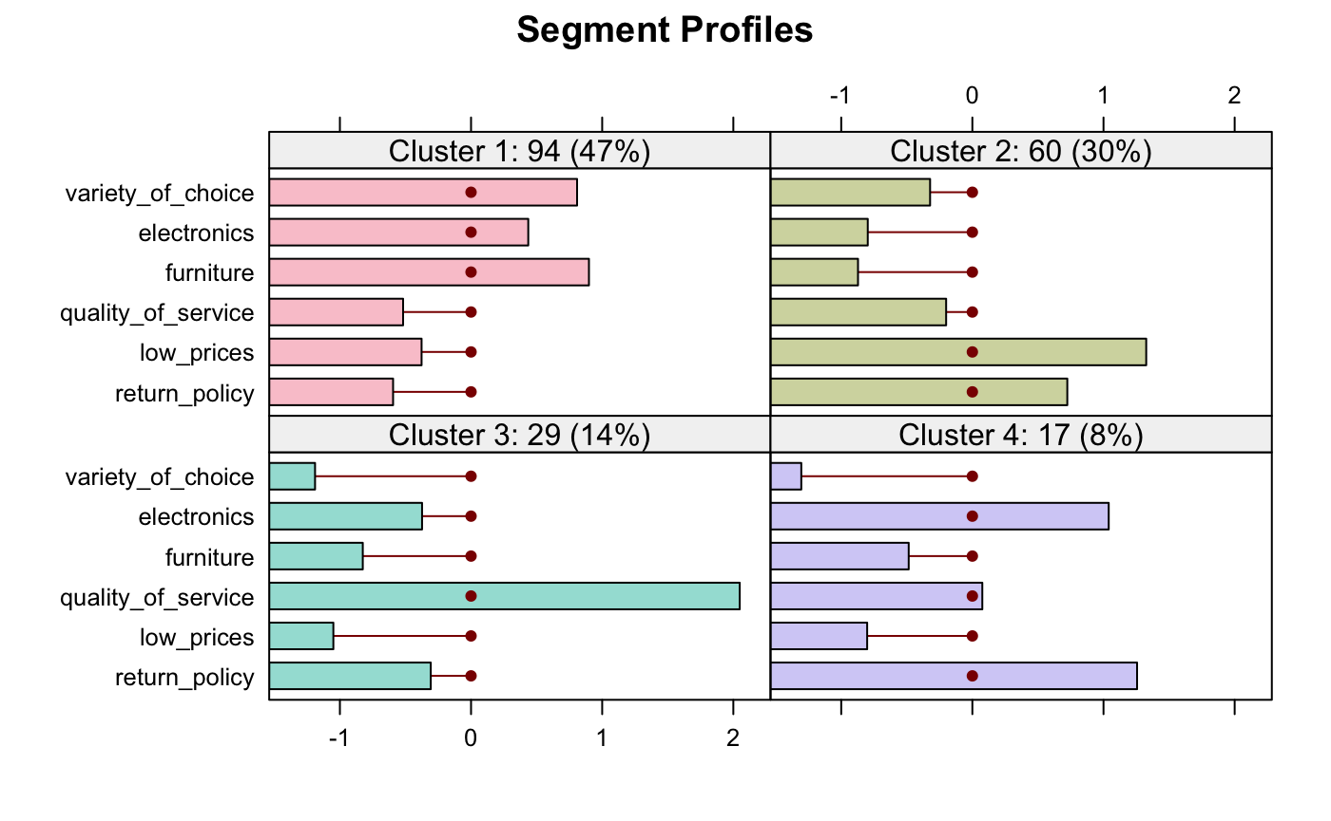

The bar chart reflects the same ordering as **hc4** clusters:

* **Cluster 1:** High variety and furniture (**Assortment Seekers**).
* **Cluster 2:** High low_prices and moderate returns (**Price-Sensitive**).
* **Cluster 3:** Very high quality_of_service (**Service Lovers**).
* **Cluster 4:** High electronics and return_policy (**Tech & Returns)**

## 2.15: Segment Naming (Unstandardized Means)

```{r}

*# Add the cluster assignment to the un-normalized data set*

retailer <- retailer %>%

mutate(cluster4 = hc4)

*# Compute the average values of the un-normalized dataset*

retailer %>%

group_by(cluster4) %>%

summarise(

*# Store attributes (raw 1–10 ratings)*

Mean_Variety = round(mean(variety_of_choice), 2),

Mean_Electronics = round(mean(electronics), 2),

Mean_Furniture = round(mean(furniture), 2),

Mean_Service = round(mean(quality_of_service),2),

Mean_Price = round(mean(low_prices), 2),

Mean_Returns = round(mean(return_policy), 2),

*# Demographics*

Mean_Income = round(mean(income), 2),

Mean_Age = round(mean(age), 2),

*# Cluster size & proportion*

N = n(),

Prop = round(n()/nrow(retailer), 2)

) -> raw_profiles

raw_profiles

```

**#OUTPUT**

|  |  |  |  |  |  |  |  |  |  |  |
| --- | --- | --- | --- | --- | --- | --- | --- | --- | --- | --- |
| **cluster4**  <int> | **Mean_Variety**  <dbl> | **Mean_Electronics**  <dbl> | **Mean_Furniture**  <dbl> | **Mean_Service**  <dbl> | **Mean_Price**  <dbl> | **Mean_Returns**  <dbl> | **Mean_Income**  <dbl> | **Mean_Age**  <dbl> | **N**  <int> | **Prop**  <dbl> |
| 1 | 9.19 | 5.30 | 5.40 | 2.33 | 3.84 | 3.03 | 31.15 | 31.65 | 94 | 0.47 |
| 2 | 6.92 | 2.90 | 1.20 | 3.07 | 8.15 | 5.73 | 19.05 | 25.53 | 60 | 0.30 |
| 3 | 4.94 | 6.47 | 2.12 | 3.71 | 2.76 | 6.82 | 45.59 | 38.59 | 17 | 0.09 |
| 4 | 5.17 | 3.72 | 1.31 | 8.28 | 2.14 | 3.62 | 54.76 | 46.21 | 29 | 0.14 |

1. **Cluster 1 (94 respondents; 47 %) – “Assortment Enthusiasts”:** captures their overriding desire for breadth of selection, which Chestnut Ridge can satisfy with its deep SKU range.

* **Variety_of_choice 9.1** (highest of all segments) and **furniture 5.40/10**: these shoppers prize an extensive product assortment above all.
* Moderate scores on electronics (5.30), price (3.84), service (2.33) and returns (3.03) indicate they’re not extreme bargain hunters or service fanatics as they simply want choice.
* **Mean income $31.15 k**, **Mean age 31.7 yrs**: a broad, middle‐income, young-adult cohort.
* Represents the retailer’s core traffic: fairly balanced demographics and broad interests.

1. **Cluster 2 (60 respondents; 30 %) – “Bargain Hunters”:** reflects their strong price orientation and willingness to return items if not satisfied.

* **Low_prices 8.15/10** (very high) and **return_policy 5.73/10**: this group is driven by bargains and expects easy returns.
* Low ratings on electronics (2.90) and furniture (1.20) show they deprioritize product breadth or premium categories.
* **Mean income $19.05 k**, **Mean age 25.5 yrs**: younger, lower-income shoppers likely constrained by budget.
* Large size but low average spends, typical of deal-driven foot traffic.

1. **Cluster 3 (17 respondents; 9 %) – “Tech & Returns Loyalists”:** emphasize their twin priorities: cutting-edge devices plus peace-of-mind returns.

* **Electronics 6.47/10** and **return_policy 6.82/10** (both highest except extremes): these are tech-savvy shoppers who count on a generous returns policy.
* Lower variety (4.94) and price sensitivity (2.76) indicate focus on electronics over décor or discounts
* **Mean income $45.59 k**, **Mean age 38.6 yrs**: mid-career professionals with disposable income to spend on gadgets.
* Small but high-value segment, likely to purchase premium electronics.

1. **Cluster 4 (29 respondents; 14 %) – “Premium Service Seekers”:** captures their willingness to trade up on service quality rather than chasing discounts.

* **Quality_of_service 8.28/10** (by far the highest): this group demands white-glove service above price or product range.
* Moderate scores on electronics (3.72) and variety (5.17) suggest service is their defining criterion.
* **Mean income $54.76 k**, **Mean age 46.2 yrs:** older, affluent customers who can pay extra for installation, warranties, and in-home support.
* A niche with strong lifetime-value potential through service add-ons.

# 

# 3. Target Segment Selection

## 3.1. GE Matrix Analysis

The four customer segments are evaluated using the **GE Matrix**, which assesses segments along two dimensions:

* **Market Attractiveness:** Segment size, growth potential, and margin opportunity.
* **Business Strength:** Chestnut Ridge’s capability to serve that segment through product breadth, service expertise, pricing, and returns infrastructure.

|  |  |  |  |  |  |
| --- | --- | --- | --- | --- | --- |
| **Segment** | **Key Attributes** | **Income/Age** | **Market Attractiveness** | **Business Strength** | **Quadrant** |
| **Assortment Seekers (47%)** | High variety, high furniture | $31.2 k / 31.7 yrs | **High** (largest, stable growth) (SAITO-CHUNG & Daily, 2024) | **High** (core competence in wide product range) | Invest |
| **Service Lovers (14%)** | Exceptional service ratings | $54.8K / 46.2 yrs | **High** (Premium margins; 73% pay more for service (PwC, 2020)). | **High** (excellent service ethos) | Selective |
| **Tech & Returns (9%)** | High electronics interest, strong returns focus | $45.6K / 38.6 yrs | **Medium–High** (premium electronics; 9% niche but high ARPU) (West, 2024) | Low (Weak electronics assortment) | Harvest |
| **Bargain Hunters (30%)** | High price-sensitivity, easy returns | $19.1K / 25.5 yrs | **Low** (low margin, high competitors) | **Low** (No cost leadership) | Harvest |

## 3.2. Key Insights & Recommended Segments

### 1. Invest: Assortment Seekers (Primary Target)

This groupoccupies 47% of customers with stable growth in a large home‐furnishings market (~$215 bn, 4% CAGR (Statista, 2024)) aligns with Chestnut Ridge’s core SKU breadth and showroom strength. Mid-income demographic ($31.2K) offers balanced margin potential (Cavusgil et al., 2018).

**Actions:**

* **Expand furniture SKUs** by 30% with private-label mid-range collections.
* **Launch AR room planner** to enhance “variety discovery” experience.
* **Introduce tiered loyalty program**: Free design consultations for $1K+ annual spend.
* **Targeted marketing**: Social media ads to 30-45 age homeowners.

### 2. Selective Investment: Service Lovers (Secondary Target)

Buyers with highest income ($55k) and service premium tolerance, willing to pay for white-glove installation or extended warranty, fits Chestnut Ridge’s growing in-store service offerings.Untapped opportunity (only 14% share) with low competitive intensity. Requires capability development to overcome current service weakness (mean rating: 3.53)

**Actions:**

* **Train "Service Concierge" teams**: 50-hour certification program
* **Launch premium offerings**
* **Partner with luxury brands**
* **Targeting**: Direct mail to ZIP codes with $75K+ median income

### 3. Harvest: Tech & Returns & Bargain Hunters

**Tech & Returns**: 35% electronics return rates erode profitability (Ballantine, 2025) while **Bargain Hunters**: 3× higher churn with 19% margin erosion (Pauwels et al., 2002).

Both segments misaligned with the company’s strategic capabilities.

**Actions:**

* **Minimize price promotions** to discourage Bargain Hunters
* **Implement restocking fees** (15%) for electronics to offset return costs
* **Redirect resources** to Invest/Selective segments

In conclusion, Chestnut Ridge should aggressively target **Assortment Seekers** (immediate growth) and strategically cultivate **Service Lovers** (long-term differentiation). This dual approach leverages existing strengths in product variety while building service capabilities to capture premium margins. Harvesting price-sensitive and electronics-focused segments preserves resources for higher-potential segments, aligning with industry shifts toward experiential retail.

# 4. References

Ballantine, C. (2025, January 14). *Latest Returns Statistics | Ecommerce Business*. Meteor Space - Warehousing & Order Fulfillment Services in Ireland & Europe: Meteor Space. <https://www.meteorspace.com/2025/01/14/latest-returns-statistics-that-may-surprise-you/>

Cavusgil, S. T., Deligonul, S., Kardes, I., & Cavusgil, E. (2018). Middle-Class Consumers in Emerging Markets: Conceptualization, Propositions, and Implications for International Marketers. *Journal of International Marketing*, *26*(3), 94–108. <https://doi.org/10.1509/jim.16.0021>

Pauwels, K., Hanssens, D. M., & Siddarth, S. (2002). The Long-Term Effects of Price Promotions on Category Incidence, Brand Choice, and Purchase Quantity. *Journal of Marketing Research*, *39*(4), 421–439. <https://doi.org/10.1509/jmkr.39.4.421.19114>

PwC. (2020). *Customer Experience Is Everything*. PWC. <https://www.pwc.com/us/en/services/consulting/library/consumer-intelligence-series/future-of-customer-experience.html>

SAITO-CHUNG, D., & Daily, I. B. (2024, April 25). *After 70% Run, Can This Retail Sector Keep Rising?* Investor’s Business Daily. <https://www.investors.com/research/ibd-industry-themes/growth-stocks-williams-sonoma-rh-gap-arhaus-ethan-allen/?utm_source=chatgpt.com>

Statista. (2024). *Home Décor - United Kingdom | Statista Market Forecast*. Statista. <https://www.statista.com/outlook/cmo/furniture/home-decor/united-kingdom>

West, P. (2024, September 26). *Consumer electronics sales to hit $977 billion in 2025 - Procurement Pro*. Procurement Pro. <https://procurementpro.com/consumer-electronics-sales-to-hit-977-billion-in-2025/?utm_source=chatgpt.com>